**SUPER RESOLUTION: A SPATIAL SUBPIXEL INTERPOLATION TECHNIQUE**

Eng. Popescu Andrei-Iulian,

Computer Science and Engineering Department, Faculty of Automatic Control and Computers,

Politehnica University of Bucharest, Splaiul Independence 313, Bucharest 060042, Romania,

[andrei.popescu96@stud.energ.upb.ro](mailto:andrei.popescu96@stud.energ.upb.ro)

Eng. Busuioc Dragos-Andrei,

Computer Science and Engineering Department, Faculty of Automatic Control and Computers,

Politehnica University of Bucharest, Splaiul Independence 313, Bucharest 060042, Romania,

[dragos.busuioc@stud.acs.upb.ro](mailto:dragos.busuioc@stud.acs.upb.ro)

Professor PhD Eng. Costin Anton Boiangiu,

Computer Science and Engineering Department, Faculty of Automatic Control and Computers,

Politehnica University of Bucharest, Splaiul Independence 313, Bucharest 060042, Romania,

[costin.boiangiu@cs.pub.ro](mailto:costin.boiangiu@cs.pub.ro)

**Abstract**

Super resolution describes the process of creating a higher resolution image using one or multiple low resolution images. In this paper we will focus on the method based on multiple low resolution images, presenting its advantages and disadvantages. Finally, we will present the challenges which future research is faced with.

The need for this field stems from applicability in important areas such as machine image perception and human image interpretation, where high end image capturing hardware isn’t feasible or cost efficient.

**Introduction**

**Problem motivation**

The main limitation of image acquisition is the imaging sensors of the device used. The modern image sensor is typically a charge-coupled device (CCD) or a complementary metal-oxide-semiconductor (CMOS) active-pixel sensor. The two types are typically arranged in a two-dimensional array to capture two-dimensional image signals. The spatial resolution of the image to capture is directly influenced by the sensor size or equivalently the number of sensor elements per unit area. Higher density of the sensors means higher spatial resolution possible for the imaging system. An imaging system with inadequate detectors will generate low resolution images with blocky effects, due to the aliasing from low spatial sampling frequency. To increase the sensor density will bring issues such as causing “shot noise” [1], increasing hardware cost and sensor size.

While the image sensors limit the spatial resolution of the image, the image details (high frequency bands) are also limited by the optics, due to lens blurs (associated with the sensor point spread function (PSF)), lens aberration effects, aperture diffractions and optical blurring due to motion. The construction of imaging chips and optical components able to capture very high-resolution images is expensive and not practical in most real applications. One example is the widely used surveillance cameras. Besides the cost, the resolution of a surveillance camera is limited in the camera speed and hardware storage.

Another way to address this problem is to accept the image degradations and use signal processing to post process the captured images, to trade off computational cost with the hardware cost. These techniques are specifically referred as Super-Resolution (SR) reconstruction.

Super-resolution (SR) us the concept of constructing high-resolution (HR) images from several observed low-resolution (LR) images, thus increasing the high frequency components and removing the degradations caused by the imaging process of the low resolution camera. By combining the non-redundant information contained in multiple low-resolution frames, we can generate a high-resolution image. A closely related technique with SR is the single image interpolation approach, which can be used to increase the image size, but without additional information provided, the quality of the single image interpolation is limited due to the ill-posed nature of the problem and in some cases add no value. In the SR setting, however, multiple low-resolution observations are available for reconstruction.

The non-redundant information contained in the these LR images is typically introduced by subpixel shifts between them. These shifts may occur due to movements of objects, or due to controlled motions, like the imaging system having a predefined speed and path. Each low-resolution frame is a decimated, aliased observation of the true scene, thus SR is possible only if subpixel motions between these low resolution frames exist.

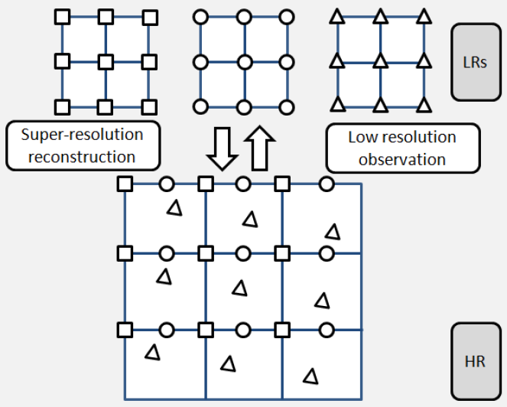

[2]

In the imaging process, the camera captures several LR frames, which are down sampled from the HR scene with subpixel shifts between each other. SR construction reverses this process by aligning the LR observations to subpixel accuracy and combining them into a HR image grid(interpolation), thereby overcoming the imaging limitation of the camera. SR (some of which described in this book), arises in many areas such as:

1. Surveillance video [3][4]: frame freeze and zoom on regions of interest (usages consist of automatic target recognition and human perception: license plates, faces etc.)
2. Medical imaging (CT, MRI, Ultrasound) [5][6]

**Related word**

Early works regarding multiframe super resolution are based upon classical flow estimation techniques with differential equations ( Lucas & Kanade. 1981 on coarse-tofine pyramidal approximation and Hom & Schunck, 1981 on regularized improvement) in order to achieve better low-resolution images with improved subpixel precision. The frequency-domain modeling of rigid transformation has been tackled by Vandewalle et al. (2016), but results have proven that these approaches are not suitable for video sequences with complex nonrigid motion.

However, recent advances in optical flow estimation manage to provide subpixel accuracy even when low-resolution frames were captured on a complex motion, as shown in D. Sun, Roth, and Black (2010) and Baker et al. (2011). This was achieved by exploiting nonlocal regularization as a generalization of median filtering for outlier rejection on a model stemming from Horn and Schunck (1981). Contemporary optical flow methods can improve accuracy with respect to classical approaches, as the motion becomes more complex, contemporary methods clearly outperform the classical ones, thanks to a greatly reduced number of outliers.

Recent methods allow a greater reduction of outliers, thanks to the edge preserving fusion of sparse feature-based matches with continuous flow fields as in the recent work by Revaud, Weinzaepfel, Harchaoui, and Schmid (2015).

The simpler and faster block matching techniques do not suffice to accurately describe the subpixel motion between frames, although there are ways to improve accuracy based on iterative refinement of matches which can provide reasonable approximation of optical flow fields.

(Salvador, Kochale, & Schweidler, 2013).

**Current State-of-the Art**

Recently, several models based on deep neural networks have achieved great success in terms of both reconstruction accuracy and computational performance in regards to super-resolution.

EDSR - In particular, residual learning techniques exhibit improved performance. Recent models of EDSR have proven significant performance by removing unnecessary modules in conventional residual networks and expanding the model size while stabilizing the training procedure.

Fast Super-Resolution Convolutional Neural Network (FSRCNN) - This method is an improved Super-Resolution Convolutional Neural Network (SRCNN) that manages to achieve real-time super-resolution while still maintaining good performance.

Deep Laplacian Pyramid Super-Resolution Network (LapSRN) - Provides fast and accurate image super-resolution, the proposed network progressively reconstructs the sub-band residuals of high-resolution images at multiple pyramid levels.

**References**

[1] Mohd Awais Farooque, Jayant S.Rohankar. SURVEY ON VARIOUS NOISES AND TECHNIQUES FOR DENOISING THE COLOR IMAGE, pages 1-2, 2013

[2] Jianchao Yang, Thomas Huang, Image super-resolution: Historical overview and future challenges, pages 6, 2017

[3] Marco Crisani, Dong Seon Cheng, Vittorio Murino, and Donato Pannullo. Distilling information with super-resolution for video surveillance. In Proceedings of the ACM 2nd International Workshop on Video Surveillance and Sensor Networks, pages 2-11, 2004

[4] Frank Lin, Clinton B. Fookes, Vinod Chandran, and Sridha Sridharan. Investigation into optical flow super-resolution for surveillance applications. In The Austrilian Pattern Recognition Society Worshop on Digital Image Computing, pages 987-995, 2005

[5] J. Maintz and M. Viergever. A survey of medical image registration. Medical Image Analysis, pages 1-36, 2008

[6] S. Peleg and Y. Yeshurun. Superresolution in MRI: application to human white matter fiber tract visualization by diffusion tensor imaging. Magnazine Resonance in Medicine, pages 29-35, 2001.

[7] Bee Lim, S. S. (2017). Enhanced Deep Residual Networks for Single Image Super-Resolution. Seoul, Korea: Department of ECE, ASRI, Seoul National University,.

[8] Chao Dong, C. C. (n.d.). Accelerating the Super-Resolution Convolutional Neural Network. Hong Kong: Department of Information Engineering, The Chinese University of Hong Kong.

[9] Horn, B. K. P., & Schunck, B. G. (1981). Determining optical flow. Artificial Intelligence, 17, 185–203

[10] Lucas, B. D., & Kanade, T. (1981). An iterative image registration technique with an application

to stereo vision. In Proceedings of the international joint conference on artificial intelligence

(p. 674–679).

[11] Vandewalle, P., Süsstrunk, S., & Vetterli, M. (2006). A frequency domain approach to registration of

aliased images with application to super-resolution. EURASIP Journal on Applied Signal Processing,

2006, 233.

[12] Sun, D., Roth, S., & Black, M. J. (2010). Secrets of optical flow estimation and their principles. In

Proceedings of IEEE conference on computer vision and pattern recognition (p. 2432–2439).

[13] Baker, S., & Kanade, T. (2002). Limits on super-resolution and how to break them. IEEE Transactions

on Pattern Analysis and Machine Intelligence, 24(9), 1167–1183.